**Preliminary Investigation report**



**TEAM**: *iTech*

* ***Yadwinder Singh Sekhon***
* ***Paramjot Singh***
* ***Maria Mathew***
* ***Husanpreet Kaur***
* ***Diljot Kaur***

**Index**

|  |  |  |
| --- | --- | --- |
| NO. | TOPIC | PAGE NUMBER |
| 1. | Cover Letter | 3 |
| 2. | Executive summary | 4 |
| 3. | Introduction | 5 |
| 4. | Client Overview | 6 |
| 5. | Current system | 8 |
| 6. | Preliminary Investigation Report | 9 |
| 7. | New System Scope | 14 |
| 8. | Recommendation | 16 |

**Cover Letter**

22 September

**E-Cleaners Incorporated 4526 Richmond Ave Scarborough, ON**

***Re: Preliminary Investigation Report***

Dear Mr and Mrs Smith

Enclosed is the preliminary investigation report of the **E-cleaner Inc.** as requested by you as a result of noticing a decline in customer satisfaction manifested by increased customer complaints.

We, the **iTech** consultants is a company that helps our clientele in creating new system or upgrading the current one. We are a customer-oriented team ensuring excellent service, that takes the time to design and create efficient solutions for companies like you based on their need and goals. We take pride in continuing to achieve persistent blooming by providing effective solutions possible to our clientele.

We keep our client’s objective and goals as our guiding factor while taking each step during the process and have helped numerous companies like you to achieve their goals and become a sustainable business in a reasonable time. A general outline of our operation includes a full assessment of the company’s current process, sales and hierarchy. Then we use our finding to understand the benefits, opportunities and threats of the current system. With all the information that we collected, we then forward a new proposal that can work as a benefit to the company in a short time and also last, paving way to a more successful business.

If you choose us to serve you, you can be sure of substantial changes in your company that satisfy your business needs. Thank you for your time and for considering the Avengers Consultants and we wish the all the success to your business and future business endeavours.

Sincerely,

**The iTech Consultants.**

**Executive Summary**

This is the general outline of the process:

 For understanding the flow of a business, we keenly analyze the procedure and also develop flow chart for existing organizational work flow, which gives a clear understanding of the process. The analysis of legacy system helps to understand the pros and cons of your system, which could help in versioning of application to get a reliable, effective and efficient software.

  This assessment provided the overview of how the transactions are done, how the orders are taken, and how the services are provided to the customers. To get a thorough understanding of the project, we did a SWOT analysis. SWOT analysis helps to define the Strength, Weakness, Opportunity and Threats of your business. This plays a crucial role in identifying which part of the business needs modification and improvements. Strengths are identified as those that bring in more customers, improve customer satisfaction and efficiency of the business. Weakness are Identified as those that hinder the growth of the business. Opportunities are identified as the areas where you can invest and improve that will bring in more revenue. Identifying the opportunities help in exploiting them to their greatest potential to benefit the company to the greatest extend possible. Also, the threats identify the possible competition from the similar businesses and failures in the future.

 After the careful assessment of your whole business we come up with a proposed plan for your business that will help you to be a sustainable business and improve in

terms of efficiency, convenience, customer satisfaction and also your satisfaction to expand your business.

  In our Preliminary Investigation report we

considered many of factors which are then jotted down into detail. These factors

are crucial in adding value to your company.

**Introduction**

The topics covered in this report are as follows;

- **Client Overview,** where the overview of the business and services provided are listed and the hierarchy of the business is analyzed by creating an organizational chart. This is vital in knowing the facts of the business that will help in the further analysis of the whole business such as S.W.O.T analysis

- **Current System**, where the current business process, its pros and cons are analyzed. It is vital in recognizing the strengths and weaknesses of the whole business.

- **Preliminary Investigation** includes S.W.O.T. analysis and feasibility study. This part helps to understand the Opportunities and Strengths that can be utilized in planning the next step ahead, and the Weaknesses and Threats that will keep us from making mistakes in the new systems. The feasibility analysis helps in evaluating the cost and practicality of the new proposed system.

- **New System Scope** is the most important section of this report as it gives a summary of the changes to be implemented in the current system and highlights its benefits and constraints if any.

- **Recommendation** is our proposal to you on what should be changed in the current system and how they can benefit you.

**Client Overview**

**The E-cleaner incorporated** is a laundering and dry- cleaning business situated in the GTA founded and managed by Mr. and Mrs. Smith. They provide laundering services for a variety of clothing items and exceptional dry-cleaning services for delicate fabrics and the clothing items that degrade in water. The actual cleaning is done in collaboration with a whole-sale cleaner. The E-cleaners also provide minimal mending services on request.

The company’s mission is to provide an efficient, hygienic oriented and superior quality laundry experience through innovative technology, cleanliness and exceptional customer service and to establish value laden relationships with its clients

As the chart below, E-Cleaners has various Departments to run their business. Mrs. Smith oversees the sales and marketing and human resource department. And Mr. Smith takes care of the accounting department. There is also a supervisor for dry cleaning and laundry department who directly reports to Mr. and Mrs. Smith.

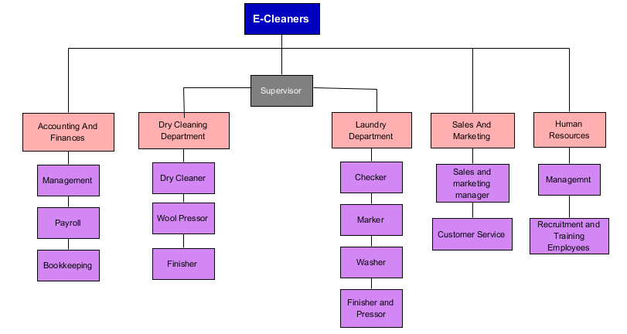

***Accounting and Finances:***

This department is responsible for all the money transactions, manual bookkeeping and invoice generation

***Dry Cleaning:***

This department sorts the clothes that has to be dry cleaned and does the actual process.

***Laundry:***

This department takes care of the clothes that has to be washed. They forward the clothes to the whole sale cleaners to get them cleaned and pressed.

***Sales and Marketing:***

This department handles customer complaints and concerns and resolves them

***Human resources:***

This management helps in finding the best employees for the company and train. They also coordinate the administrative functions of a company.

**Current System**

Everything in the current system is manual starting from the invoice generation to account keeping and all the interactions are in person, there is no online booking or door to door services.

In the current system the client drops off their laundry for cleaning and pick it up at a later date.  When the items are dropped, the client’s first and last name and phone number is collected and is written on a slip of paper which also includes all of the details of the dropped off items. The client pays for the cleaning, which is accepted in debit, credit or cash and a receipt is given to them. Then, a pick-up date is assigned. If they do not show up on the specified pick-up date, the company calls them to remind them of the pick-up. Also, If the items are not picked up after 5 months, the company sell the items to a distributor.

The disadvantage of the current manual system is that the files and records take up a lot of space and are at a risk of being lost, damaged or misplaced. Also, it is hard to make changes. Furthermore, the manual account keeping means that there is a high risk of inaccuracies in the system. Also, the business is unable to keep track of the expenses and profits. The security of the information is also at stake.

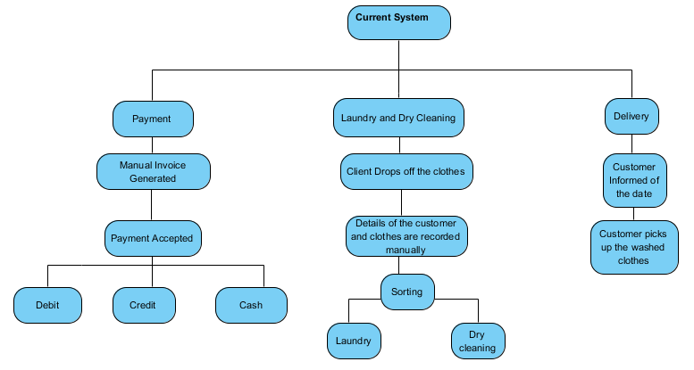

**Preliminary Investigation**

**Findings**

**SWOT ANALYSIS**

|  |  |
| --- | --- |
| **Helpful**  in achieving the objective/goals | **Harmful**  in achieving the objectives/ goals |
| **STRENGTHS:**  **✓** Automated payment system  **✓** Providing extended and related services  **✓** Attractive promotional prices and categorization of clothes and its service prices | **WEEKNESSESS**:  **✓** Manual accounting system  **✓**Manual record keeping of the customers  **✓**Lack of home delivery and pick-up services  **✓**No marketing | **Internal Factors** |
| **OPPORTUNITIES**:  **✓** Increasing number of populations in GTA  **✓**Huge number of hotels around  **✓**Demands for mending stations, stain removal and ironing | **THREATS**:  **✓**Competition from well-established firms  **✓**The rising popularity of do-it-yourself laundry shops  **✓**New entrants | **External Factors** |

*In Detail:*

**STRENGTHS**

**1. Automated payment system:**

As the only thing automated, it is the greatest strength of the E-cleaner company.

The company accepts payment in debit, credit and cash increasing convenience and flexibility and giving customers the freedom to choose based on their needs. The automated system also eliminates the chances of human errors and saves time to calculate the balance amount due to its clients.

**2. Providing extended and related services.**

The company provides extra services such as mending minor damages to the clothes upon request, exposing the convenience of the whole business. The company also provides exceptional dry-cleaning services for delicate fabrics and the clothing items that degrade in water. All showing the diversity of the services provided.

**3. Attractive promotional prices and categorization of clothes and its service prices:**

The E-cleaner company provides promotional prices upon dropping laundry in bulk.

For example, the promotional service charge for cleaning three shirts is $18 whereas the regular price for cleaning one shirt is $7, which certainly will attract more customers. This will also bring more revenue and cash flow in short time and also helps in maintaining an ongoing relationship with the customers and increases the chances of bringing in more loyal clients. The company also has different pricing for items based on its size and the materials, which depicts the careful organization and planning from the management side.

**WEAKNESSES**

**1. Manual accounting system**

This is the major weakness of the company. The business definitely finds the manual account keeping tedious. There is a high risk of inaccuracies in the system that can be caused by human errors like entering information into wrong accounts, recording information backwards and transposing figures. There is no possibility for internal checks and balances. The business is unable to keep track of the expenses and profits or volume of sales by item or by client. Also, the use of paper journals or ledgers means that it takes a huge amount of time to locate them prior to entering records. The security of the information is also at stake.

**2. Manual record keeping of the customers**

The absence of electronic documentation system is also a weakness in the business. The files and records take up a lot of space and are at a risk of being lost, damaged or misplaced. Also, it is hard to make changes and so the editing process is more time consuming than working with digital copies. It is also difficult to systematically organize the data. The large number of files means that you need more time to hunt down the information. Also, the use of paper and ink contributes added expenses.

**3. Lack of home delivery and pick-up services**

Customers prefer a service that comes over to the house to pick their laundry and deliver it back to them once they’re all cleaned. Due to the total absence of this essential service, the business is suffering a major setback in terms of convenience and customer satisfaction. The company often have to deal with washed clothes that are not picked up on time and have to call the customers to remind them, which is time consuming.

**4. No marketing**

The company has less or no marketing. The only means of reaching new customers is by recommendation from the already existing customers. This is a huge setback as the company fails to attract enough customers. The company also has no website or social media pages or any kind of means for promoting business.

**OPPORTUNITIES**

**1. Increasing number of populations in GTA**

In GTA many are the working professionals with busy schedule. And for them laundry services have become something necessary in their life and so there is always a constant and consistent market demand for laundry services. The company can exploit this opportunity and resolving the weakness and other problems that it faces now means that a huge market is waiting for them. Introducing a delivery service and with its already affordable and promotional prices there will be no dearth of customers.

**2. Huge number of hotels around**

The city has a huge number of hotels and spas. With good marketing and introducing attractive offers and promotions the company can surely get a huge amount of business from them.

**3. Demands for mending stations**

The company now has only facilities to do minimal mending facilities. If improvements are done in this area there will definitely be an increase in business as it adds on to the overall convenience of the business and people tend to go to companies that offer multiple services.

**THREATS**

**1. Competition from well-established firms**

There are many well-established laundry shops in and around Toronto. With their high convenience due to the multiple services and discounts they offer, they are a threat to E-cleaners. Also, most of them offer automated and smart laundry and dry-cleaning services, which means high efficiency, that the E-cleaners lack. And so, the company needs to improve substantially in terms of technology and convenience in order to cope with the existing competition.

**2.The rising popularity of do-it-yourself laundry shops**

Because the self-service laundromats are quick and convenient it is attracting more individuals than the laundry shops. The average time to wash and dry cloths in self-service laundromats is just an hour.

**3.New entrants**

There also a constant threat from new entrants as there are less barriers of entry.

**CLIENT’S VISION, MISSION AND GOALS**

**Vision**

To be the most preferred company offering fast, professional, convenient and affordable Laundry and dry-cleaning services in GTA.

**Mission**

To provide an efficient, hygienic oriented and superior quality laundry experience through innovative technology, cleanliness and exceptional customer service and to establish value laden relationships with its clients.

**Goals**

* To grow into a sustainable business by the end of the year.
* To provide exceptional customer service and improve customer satisfaction and accept feedback by introducing online rating and recommendation system.
* To improve convenience by providing services ranging from washing and drying to optional folding and mending and also pick-up and delivery services.
* To improve the efficiency of the entire business by automation.
* To develop a system that is user friendly to reduce the calculation error for the payment receipts.
* To achieve efficient data saving of the customer’s records.
* To increase the overall productivity of the staffs.

**FEASIBILITY**

**Estimated cost in the process of developing the proposed system.**

* **Hardware and Software costs**

Estimatedtotal: CAD 150,0000

* **Maintenance costs**

Estimated total: CAD 80,000

* **System Analyst**

Wage: CAD 32 /Hour

Annual Cost: CAD 65,950

* **Project Manager**

Wage: CAD 31/Hour

Annual Salary: CAD 62,612

* **Accountant**

Wage: CAD 21/Hour

Annual Cost: CAD 50,100

* **Technician**

Wage: CAD 16/Hour

Annual Salary: CAD 14,200

**Expected benefits**

***Tangible:***

* Reduce paper-based transactions and errors caused by it.
* Reduce errors in accounting.
* Increased earnings due to improved technology.

***In-Tangible***

* Reduce Customer complaints and improve customer satisfaction.
* Save time and effort in data entry.
* More timely information.

**Time Required for the process of developing the proposed system**

|  |  |
| --- | --- |
| **PHASE** | **TIME** |
| * **System Planning** | * **14 days** |
| * **System Analysis** | * **30 days** |
| * **System Design** | * **70 days** |
| * **System Implementation** | * **90 days** |

|  |  |
| --- | --- |
| **TOTAL:** | **204 days** |

**New System Scope**

**PROPOSED CHANGES TO THE CURRENT SYSTEM**

* 1. **Implementation of an accounting software**

***Reason to consider:***

* Difficulty in accounting as reported by the E-Cleaner as it is manual
* Difficulty in keeping track of the income, expenses, taxes, and volume of sales by item or by clients with the current manual method.
* Difficulty in tracking the overall profitability of the system

***Benefits of the change:***

* Simplicity of data entry
* Saves a huge amount of time over manual bookkeeping
* Increased speed in generating an invoice
* Stores invoices and bills efficiently and easy to retrieve
* Reduces the chances of errors in accounting and easier to find errors
* Helps in keeping track of the sales, income, expenses, debts or the sales by volume and by clients (which is important to the E-cleaners) and also the overall profitability of the business.

***Constraints:***

* Costlier than the paper-based system.
* Yearly maintenance and support required
* Cost for implementation of the software
* the necessity of hiring an accountant

**2.** **Switching to electronic document management system software from manual record keeping**

***Reason to consider:***

* The paper files take lot of space and are at a risk of being misplaced, damaged or lost.
* Editing and retrieving files are also a tedious process with the current system.

***Benefits of the change:***

* Less storage space required.
* Improved security
* Easier retrieval of required data
* Better backup and recovery of data

***Constraints***

* The hardware and software costs.
* May need to update the software often as it becomes outdated
* Slowing down of the software due to large amount of unnecessary data.

**3. Introducing additional services such as mending and folding**

***Reason to consider:***

* Less convenience and customer satisfaction of the current system.

***Benefits of the change:***

* Increased revenue and customer satisfaction
* Increased business due to improved convenience

**4. Creating a marketing plan**

***Reason to consider:***

* Failure to attract customers
* Lack of awareness about the E-Cleaner business in the city

***Benefits of the change:***

* Help in determining the target customers
* Increases publicity of the business
* Attracts more customer

***Constraints***:

* Identifies the weaknesses in the business
* Can influence the business negatively if the information is interpreted wrongly.

**Recommendations**

The current manual system is not efficient and does not satisfy the business needs. It has many weaknesses as mentioned previously in the report. With the current system the company is not capable of achieving its goal or improving customer satisfaction. There is a necessity of implementing a computerized system to improve the efficiency of the whole business. This will be an important element in leading the company to a sustainable business in the near future.

Based on the information gathered for the investigation report. We propose the implementation of an accounting software and electronic documentation system, which help you achieve the following:

* Increased efficiency of the whole system
* More accurate, simple and less time-consuming account keeping.
* Shortens invoice generating time
* Easy access of data
* Enable simpler and easy modification of data
* Increased security of data
* Enables in keeping track of profits and expenses.
* Increase work efficiency and productivity
* Saves space and time